**AN INTERNSHIP ON**

**Tech Review**

***An internship report submitted to***

**JAAHARLAL NEHRU TECHNOLOGICAL UNIVERSITY-KAKINADA, KAKINADA**

***Submitted in partial fulfillment of the requirements for the award of degree***

# BACHELOR OF TECHNOLOGY

**IN**

**INFORMATION TECHNOLOGY**

**B.Tech – II Semester Submitted by**

**GATTE PUSHPA SRI (22KN1A1233)**

**GOLI HARINI (22KN1A1236)**

**MALLADI NARENDRA (22KN1A1259)**

**DOODICHINTALA S.N.V.SAI (22KN1A1225)**

***Under the esteemed Guidance of***

**Mr. A. Ravi Kiran**

**Assistant Professor**



**Department of Information Technology**

**NRI INSTITUTE OF TECHNOLOGY**

**(AUTONOMOUS)**

**Approved by AICTE, New Delhi :: Permanent Affiliation to JNTUK, Kakinada**

**Accredited by NBA (CSE, ECE & EEE), Accredited by NAAC with A-Grade**

**An ISO 9001:2015 certified Institution**

**Pothavarappadu (v), Via Nunna, Agiripalli (M), PIN-521212.**

**Ph:0866-2469666|email :** [**nrihitech@rediffmail.com**](mailto:nrihitech@rediffmail.com)

**Website:www.nrigroupofcolleges.com (2022-2026)**

**NRI INSTITUTE OF TECHNOLOGY**



**(AUTONOMOUS)**

**Approved by AICTE, New Delhi :Permanent Affiliation to JNTUK, Kakinada**

**Accredited by NAAC with “A” Grade,Accredited by NBA(CSE,ECE & EEE)** **An ISO 9001:2015 Certified Institution**

**Pothavarappadu (V),Agiripalli (M),Eluru District,A.P.,India,PIN-521 212**

**URL:www.nriit.edu.in,email:principal@nriit.edu.in, Mobile:+91 8333882444**

# Certificate

This is to certify that the “Internship report” submitted by **GATTE PUSHPASRI** **(22KN1A1233) ,** **GOLI HARINI (22KN1A1236) , MALLADI NARENDRA (22KN1A1259)**

**DODDICHINTHALA S.N.V.SAI(22KN1A1225)** is work done by them and submitted during

2022-2023 academic year, in partial fulfillment of the requirements for the award of the degree of

BACHELOR OF TECHNOLOGY in INFORMATION TECHNOLOGY, at ADVAITA GLOBAL -IT LABS Pvt.Ltd.



**INTERNSHIP COORDINATOR** **INTERNAL GUIDE**

**(Mr. A.Ravi Kiran)**

**ASSISTANT PROFESSOR**

**ACADEMIC COORDINATOR** **HEAD OF THE DEPARTMENT**

**(Dr .J.Rajendra prasad)**

**PROFESSOR** **PROFESSOR & HOD**

**EXTERNAL EXAMINER**

## Certificates of internship



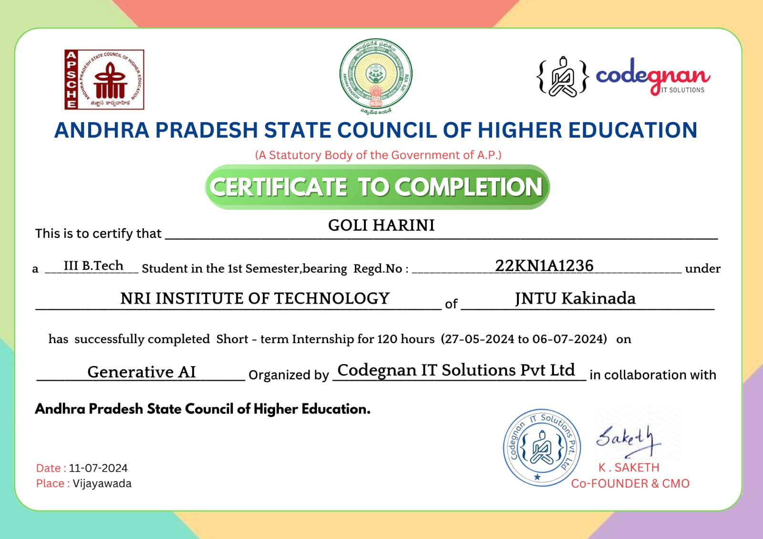

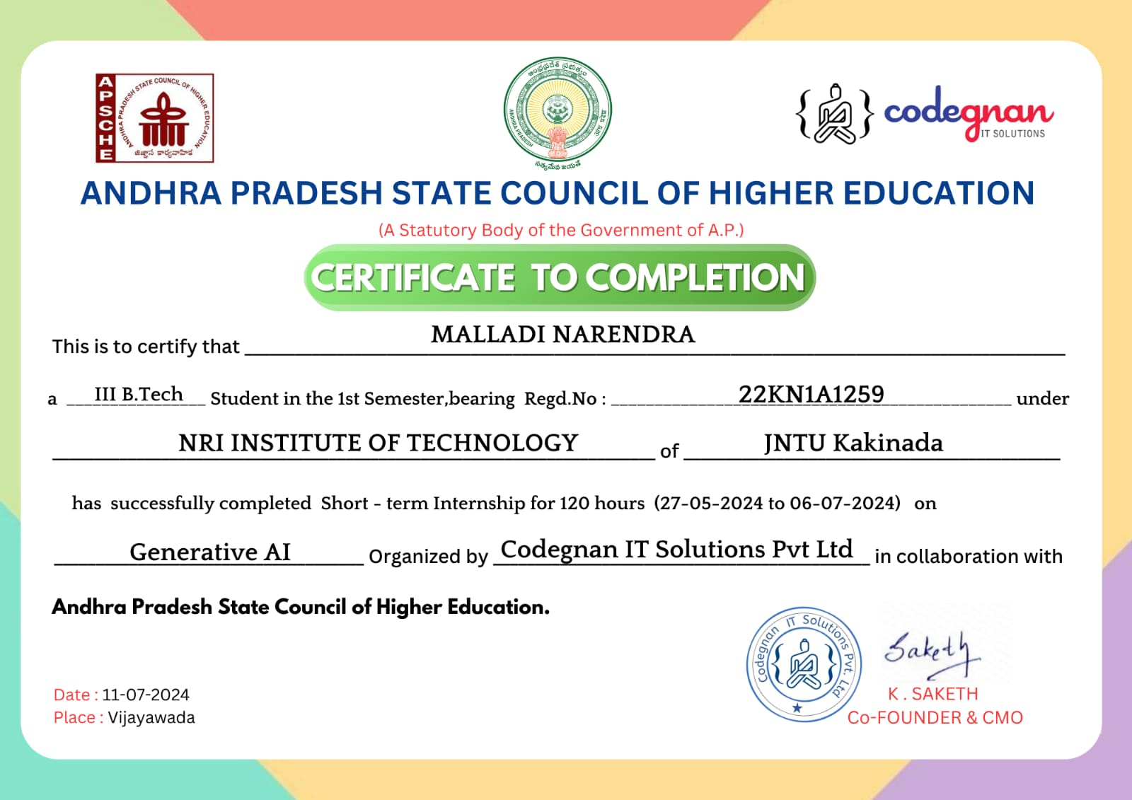

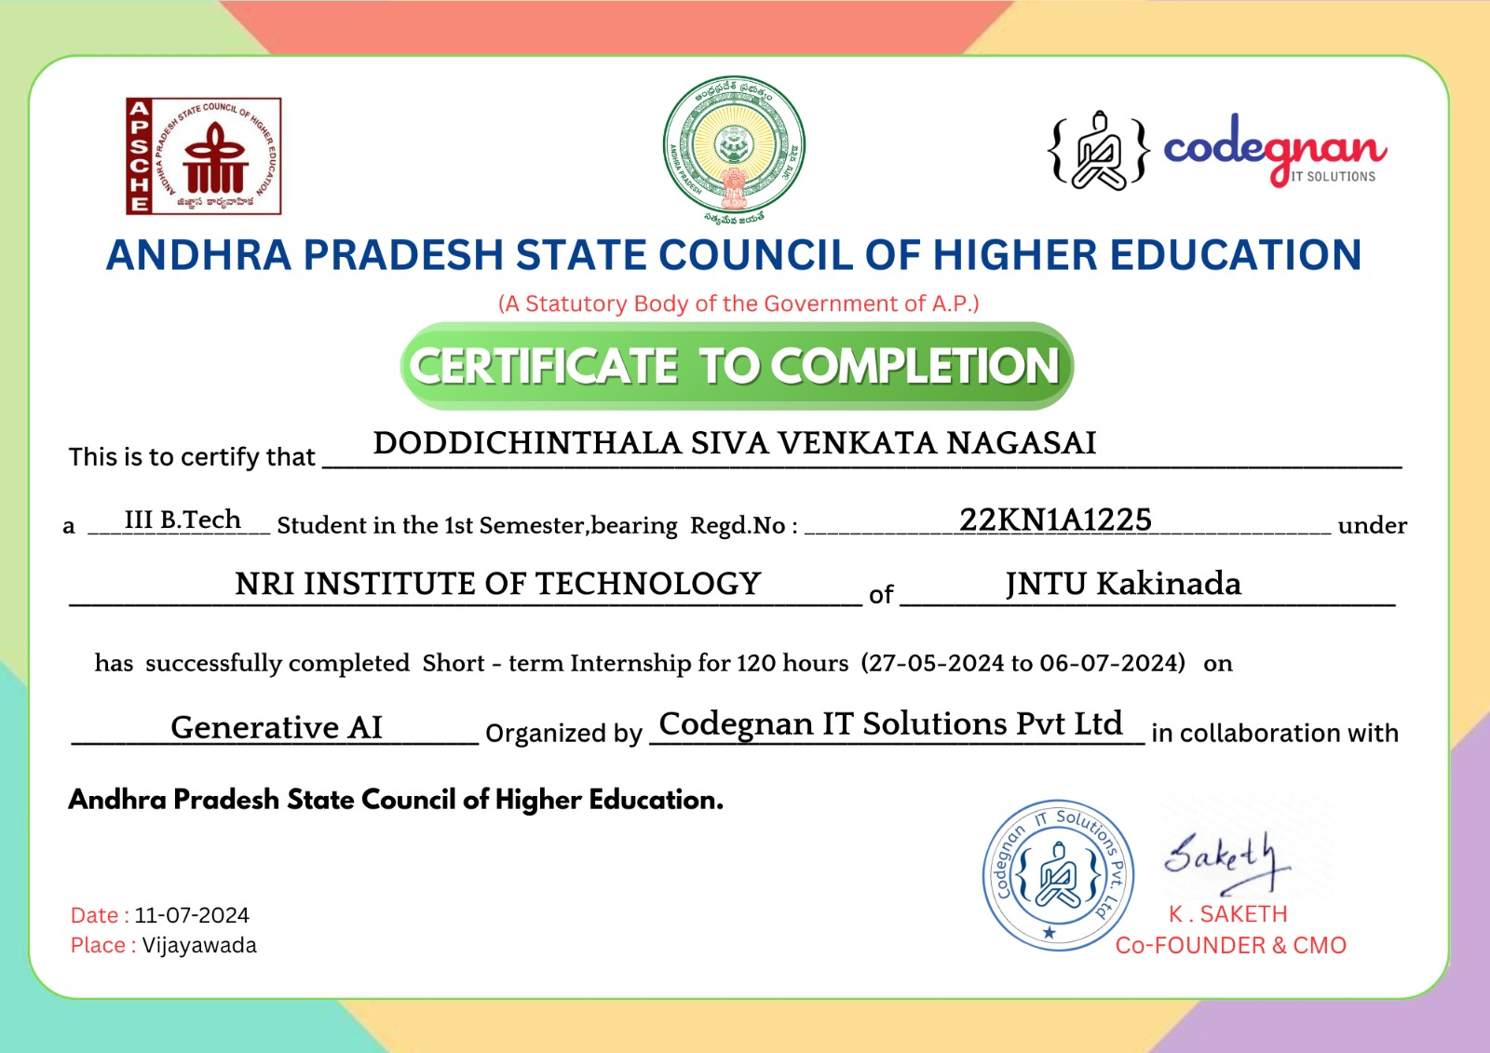

### RACKNOWLEDGMENT

Before getting into the thickest of things, we would like to thank the personalities who were part of my project in numerous ways, those who gave me outstanding support from the birth of the project.

We are extremely thankful to our beloved **Chairman Dr. R.Venkat Rao** for providing necessary infrastructure and resources for the accomplishment of our project at **NRI Institute of Technology,Agiripalli**.

We are highly indebted to **Dr.C.Naga Bhaskar, Principal of NRI Institute of Technology,** for his support during the tenure of the project.

We here by wish to express our deep sense of gratitude to **Dr. J.Rajendra Prasad, Professor and Head of the Department,** Department of Information Technology, NRI Institute of Technology for the esteemed guidance, moral support and invaluable advice provided by them for the success of the project.

With grateful thanks, I express my deep sense of gratitude and respect towards my internal guide, **Mr.A.Ravi Kiran**, **Assistant Professo**r for his valuable suggestions,guidance and encouragement throughout the project.

We are also thankful to all the staff members of Information Technology department who have cooperated in making our project a success. We would like to thank all our parents and friends who extended their help, encouragement and moral support either directly or indirectly in our project work.

|  |  |
| --- | --- |
| **NAME:**GATTE PUSHPASRI | **Redg No:**22KN1A1233 |
| **NAME:**GOLI HARINI | **Redg No:**22KN1A1236 |
| **NAME:**MALLADI NARENDRA | **Redg No:**22KN1A1259 |
| **NAME:**DODDICHINTALA S.N.V.SAI | **Redg No:**22KN1A1225 |

**Organization Information:**

ADVAITA GLOBAL IT SOLUTIONS was established with the goal of fostering the growth of a vibrant ecosystem that includes individuals, research institutes, commercial enterprises, and educational establishments. The International Institute of Technology and the Government International Institute of Digital Technologies depend on it as a primary partner. It does this by providing a platform called TAPTAP AI Driven employability, which helps students change their course toward their desired goals while also supporting human resources managers in recruiting the best individuals It is home to the most comprehensive network of centers of excellence in emerging technologies in all of India. It is common knowledge that we are one of the most successful companies in India that specializes in the production of web apps. Our goal is to create web applications that are not only reliable and productive, but also perfectly cater to the requirements of each of our customers in the most fruitful manner that is open to us.

**Programs and opportunities:**

This ground-up approach helps us deliver not only the solution to our clients but also add value to at the core which operates in Five specific domains namely TapTap - AI Driven, Post Graduation Programs, Center of Excellence, Virtual Programming Labs and Happie Days - A social Networking site for the students. TapTap offer services in Campus Recruitment drives for the Employers as well as College authorities. Recruiters can Conduct Customized Online

Assessments secured with Best-in-class Proctoring and Schedule the endto-end hiring process. Under each division we further provide specific industry solutions on focused domains with cutting edge technologies. It emphasize on building relationships with our clients by delivering projects on time and within budget**.**

**ABSTRACT**

Tech reviews play a critical role in helping consumers and professionals make informed decisions about the latest gadgets and devices. This review focuses on systematically analyzing a chosen device, encompassing its design, functionality, performance, and value. The process involves generating a detailed review based on technical specifications, user experience, and real-world testing. It also includes a personal opinion highlighting strengths, weaknesses, and unique features, followed by a comparative analysis with similar devices in the market. This structured approach ensures a balanced perspective, catering to diverse user needs, and empowering buyers to select the best technology that aligns with their goals and expectations.

#### Learning Objectives/Internship Objectives

1. Internships are generally thought of to be reserved for college students looking to gain experience in a particular field. However, a wide array of people can benefit from Training Internships in order to receive real world experience and develop their skills.
2. An objective for this position should emphasize the skills you already possess in the area and your interest in learning more.
3. Internships are utilized in a number of different career fields, including architecture, engineering,healthcare, economics, advertising and many more.
4. Some internship is used to allow individuals to perform scientific research while others are specifically designed to allow people to gain first-hand experience working.

Utilizing internships is a great way to build your resume and develop skills that can be emphasized in your resume for future jobs. When you are applying for a Training Internship, make sure to highlight any special skills or talents that can make you stand apart from the rest of the applicants.

#### WEEKLY OVERVIEW OF INTERNSHIP ACTIVITIES

|  |  |  |  |
| --- | --- | --- | --- |
| WEEK | DATES | DAY | NAME OF THE TOPIC |
| 1ST WEEK | 27.05.2024 | TUESDAY | CONTENTDELIVERY |
|  | 28.05.2024 | WEDNESDAY | CONTENTDELIVERY |
|  | 29.05.2024 | THURSDAY | CONTENTDELIVERY |
|  | 30.05.2024 | FRIDAY | CONTENTDELIVERY |
|  | 1.06.2024 | SATURDAY | CONTENTDELIVERY |

|  |  |  |  |
| --- | --- | --- | --- |
| 2ND WEEK | 3.06.2024 | MONDAY | INTRODUCTION OFTOPIC |
|  | 4.06.2024 | TUESDAY | INTRODUCTION OFTOPIC |
|  | 5.06.2024 | WEDNESDAY | INTRODUCTION OFTOPIC |
|  | 6.06.2024 | THURSDAY | INTRODUCTION OFTOPIC |
|  | 7.06.2024 | FRIDAY | INTRODUCTION OFTOPIC |
|  | 8.06.2024 | SATURDAY | INTRODUCTION OFTOPIC |

|  |  |  |  |
| --- | --- | --- | --- |
| 3RD WEEK | 10.06.2024 | MONDAY | ABSTRACT BUILDING &ABSTACT  SUBMISSION |
|  | 11.06.2024 | TUESDAY | ABSTRACT BUILDING &ABSTACT  SUBMISSION |
|  | 12.06.2024 | WEDNESDAY | ABSTRACT BUILDING &ABSTACT  SUBMISSION |
|  | 13.06.2024 | THURSDAY | ABSTRACT BUILDING &ABSTACT  SUBMISSION |
|  | 14.06.2024 | FRIDAY | ABSTRACT BUILDING &ABSTACT  SUBMISSION |
|  | 15.06.2024 | SATURDAY | ABSTRACT BUILDING &ABSTACT  SUBMISSION |

|  |  |  |  |
| --- | --- | --- | --- |
| 4TH WEEK | 17.06.2024 | MONDAY | Structure of project&data preprocessing&performance analysis,PPT presentatiom |
|  | 18.06.2024 | TUESDAY | Structure of project&data preprocessing&performance analysis,PPT presentatiom |
|  | 19.06.2024 | WEDNESDAY | Structure of project&data preprocessing&performance analysis,PPT presentatiom |
|  | 20.06.2024 | THURSDAY | Structure of project&data preprocessing&performance analysis,PPT presentatiom |
|  | 21.06.2024 | FRIDAY | Structure of project&data preprocessing&performance analysis,PPT presentatiom |
|  | 22.06.2024 | SATURDAY | Structure of project&data preprocessing&performance analysis,PPT presentatiom |

|  |  |  |  |
| --- | --- | --- | --- |
| 5thweek | 24.06.2024 | MONDAY | MidReview&Building&Applying  Algorithm |
|  | 25.06.2024 | TUESDAY | MidReview&Building&Applying  Algorithm |
|  | 26.06.2024 | WEDNESDAY | MidReview&Building&Applying  Algorithm |
|  | 27.06.2024 | THURSDAY | MidReview&Building&Applying  Algorithm |
|  | 28.06.2024 | FRIDAY | MidReview&Building&Applying  Algorithm |
|  | 29.06.2024 | SATURDAY | MidReview&Building&Applying  Algorithm |

|  |  |  |  |  |  |
| --- | --- | --- | --- | --- | --- |
| 6th WEEK | 1.07.2024 | MONDAY | Concluding  Review | The | Project,Final |
|  | 2.07.2024 | TUESDAY | Concluding  Review | The | Project,Final |
|  | 3.07.2024 | WEDNESDAY | Concluding  Review | The | Project,Final |
|  | 4.07.2024 | THURSDAY | Concluding  Review | The | Project,Final |
|  | 5.07.2024 | FRIDAY | Concluding  Review | The | Project,Final |
|  | 6.07.2024 | SATURDAY | Concluding  Review | The | Project,Final |

## INDEX

|  |  |  |
| --- | --- | --- |
| **S.NO** | **DESCRIPTION** | **PAGE NO** |
| 1 | Introduction | 1 |
| 2 | Related work | 2-6 |
| 3 | TOOLS USED | 7 |
| 4 | Software Requirements | 8 |
| 5 | Literature Review | 9-10 |
| 6 | Uml diagrams | 11-15 |
| 7 | Coding | 16-21 |
| 8 | Results | 22-26 |
| 9 | Challenges Faced | 27 |

|  |  |  |
| --- | --- | --- |
| 10 | Conclusion | 28 |
| 11 | Future Scope | 29 |
| 12 | References & Appendix | 30 |



### 1. INTRODUCTION

#### 1.CONTEXT

The rapid pace of technological innovation has led to a vast array of devices across various categories, such as smartphones, laptops, wearables, and home appliances. Each device comes with unique features, specifications, and price points, making the decision-making process overwhelming for consumers. In addition, the vast amount of information available online often results in information overload, where users struggle to identify reliable and relevant content.

Traditionally, consumers rely on individual sources such as expert reviews, user reviews, blogs, or product descriptions to guide their purchase decisions. However, these sources are often fragmented, biased, or too technical for the average consumer to understand. Additionally, the lack of a unified platform to aggregate these diverse opinions makes it harder for users to get a holistic view of a product's performance, reliability, and user satisfaction.



The Tech Review project addresses these challenges by offering a centralized platform where users can:

1. Explore a wide range of tech devices and learn about their key features.
2. Access aggregated reviews from multiple credible sources, presenting a balanced perspective.
3. Contribute personal opinions, enabling the creation of a diverse review ecosystem.
4. Compare various viewpoints, including expert insights and peer reviews, to make informed decisions*.*



#### 2.RELATED WORK

##### 2.1 WATERFALL MODEL

The Waterfall Model, a linear and sequential development methodology, is relevant to this project as it provides a structured framework for systematically building the Tech Review platform. By dividing the development process into distinct phases—requirement analysis, system design, implementation, integration and testing, deployment, and maintenance—the model ensures that each stage is thoroughly completed before moving to the next. This approach is particularly suitable for the project as it emphasizes clear planning, defined milestones, and comprehensive testing, ensuring a high-quality and user-centric final product.

##### 2.2 AGILE MODEL

Agile methodology is a flexible, iterative approach to project management and software

development that prioritizes adaptability, collaboration, and customer satisfaction. Unlike traditional linear models, Agile breaks the project into smaller, manageable increments called sprints, each typically lasting 2-4 weeks. This method ensures that functional modules are delivered at regular intervals, enabling continuous improvements based on real-time feedback. For the Tech Review project, Agile serves as an ideal framework to develop key features like device selection, review generation, opinion writing, and comparison tools. The process begins with meticulous sprint planning, where goals for the upcoming iteration are set, followed by designing wireframes and prototypes to visualize the features. The development phase involves coding and integrating these features into the platform, ensuring they align with user expectations and project goals. Rigorous testing is conducted during each sprint to identify and resolve bugs, optimize performance, and refine the user experience. After deploying the functional increment, user feedback is collected and analyzed during the review phase, guiding improvements and setting priorities for the next sprint. This iterative cycle allows the project to remain flexible, accommodating changes in technology trends, user needs, or market demands. By delivering incremental updates and maintaining constant communication among team members and stakeholders, Agile ensures that the Tech Review platform evolves into a highquality, user-focused solution tailored to its audience.



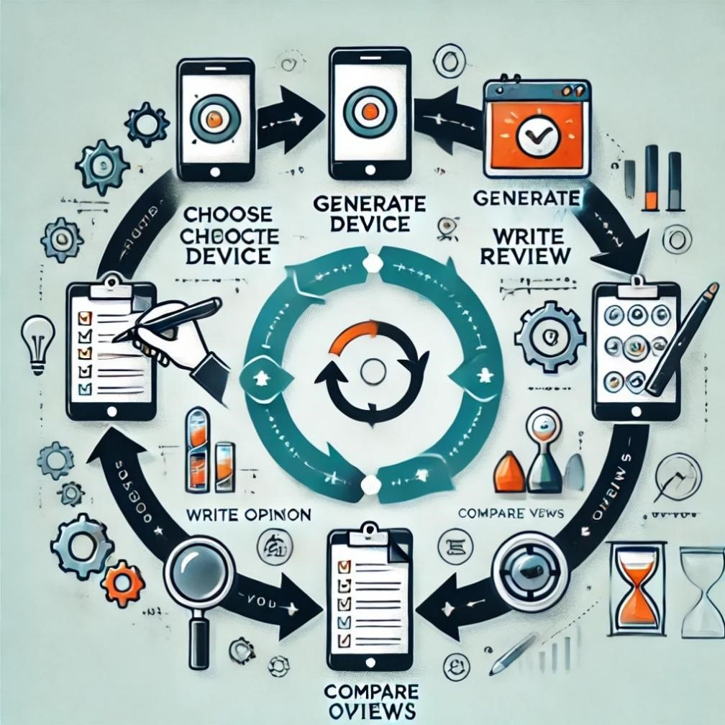

***Figure2.2:Agile model***

###### 2.3 Rapid Application Development (RAD)

Rapid Application Development (RAD) is a methodology that emphasizes quick development and delivery of software through iterative prototyping and user feedback. For the Tech Review project, RAD is particularly effective because it enables the development of key features such as device selection, review generation, opinion writing, and comparison tools in a phased, modular manner. The process begins with defining requirements through collaboration with stakeholders, followed by rapid prototyping to create functional models of specific features. These prototypes are refined through iterative cycles, incorporating user feedback to improve functionality and usability. RAD’s focus on parallel development streams and time efficiency allows for a faster delivery of a functional platform without compromising on quality. By continuously integrating and testing components, RAD ensures a user-focused, adaptable solution that evolves with the needs of its audience**.**



###### 2.4 Model-View-Controller (MVC) Architecture

The Model-View-Controller (MVC) architecture is a design pattern that helps organize an application by separating it into three main components: Model, View, and Controller. The Model is responsible for managing the data and logic of the application. For the Tech Review platform, this includes tasks like storing and updating reviews, ratings, and user inputs in the database. The View takes care of the user interface, meaning it is responsible for showing information to users in an easy-to-understand way, such as displaying reviews, ratings, and comparison charts on the screen. The Controller acts as the middleman, handling user interactions like button clicks or search requests. It takes these inputs, updates the Model if necessary, and ensures the correct information is displayed on the View. By keeping these components separate, the MVC architecture makes the application more organized, easier to develop, and simpler to maintain. For example, if you need to change how the data is displayed or update the logic behind generating reviews, you can do so without affecting the other parts of the system. This structure is especially useful for a platform like Tech Review, where both the backend (data processing) and frontend (user interface) need to work together smoothly.





#### 3.TOOLS USED

##### 3.1 Pandas

Pandas is a powerful Python library used for data manipulation and analysis. In the Tech Review System, Pandas plays a crucial role in managing the dataset of products, categories, and user reviews. It is used to load the dataset from a CSV file, filter data dynamically based on user selections, and update the dataset with new user feedback. The library's ability to handle structured data efficiently makes it a vital tool for the seamless operation of this system.

##### 3.2 Tkinter

Tkinter is the standard GUI library for Python, used to create the Tech Review System's user interface. It provides various widgets such as buttons, labels, dropdowns, and list boxes to enable user interaction. Tkinter ensures a user-friendly platform, allowing users to browse categories, view product details, and submit feedback. Its simplicity and integration with Python make it an excellent choice for building interactive applications.

##### 3.3 ImageTk (from PIL)

ImageTk is part of the Python Imaging Library (PIL) and is used for displaying images in GUI applications. In the Tech Review System, ImageTk is utilized to load and display the system’s logo, enhancing the visual appeal of the interface. By integrating images effectively, ImageTk contributes to creating a professional and engaging user experience.



### 4.SOFTWARE REQUIREMENTS

#### *1. Operating System*

* **Windows**: Preferred for easy setup of GUI libraries like Tkinter.
* **Linux/MacOS**: Compatible but may require additional steps for library installations.

#### *2. Programming Language*

• **Python**: The entire system is implemented in Python, leveraging its robust libraries and community support.

#### 3. Required Libraries and Dependencies

* **Pandas**: For data manipulation and analysis, including loading, filtering, and updating datasets.
* **Tkinter**: For creating the graphical user interface, enabling interaction between users and the system.
* **Pillow (PIL)**: Specifically, the ImageTk module is used for displaying images like logos in the GUI.
* **Messagebox**: A built-in module of Tkinter used for displaying notifications, alerts, and errors.
* **Random**: A Python standard library for generating random data for the dataset, such as prices and reviews.

#### 4*.* Data Storage

• **CSV File**: The dataset of products, categories, and user feedback is stored in and retrieved from a CSV file (large_combined_products_reviews.csv).

#### *5*. Development Environment

* **Integrated Development Environment (IDE):**
  + PyCharm
  + Visual Studio Code
  + Jupyter Notebook (optional for debugging and dataset testing)
* **Python Environment Manager:**

o pip (Python’s package installer) for installing libraries like Pandas and Pillow.

#### 6. I*mage Files*

• A logo file (e.g., nri logo.jpg) to display in the application GUI. This enhances branding and interface aesthetics.

#### *7. Additional Tools*

* **Text Editor**: For editing scripts (dataset.py and gui.py).
* **Spreadsheet Software (optional**): For viewing and manually editing the CSV file

#### Optional Software Enhancements

* Version Control System: Git, for tracking changes and collaborating on the project.
* Virtual Environment: Virtualenv or Conda, to isolate dependencies and avoid conflicts.

These requirements ensure a smooth setup and functioning of the Tech Review System.



### 5. LITERATURE REVIEW

The Tech Review System lies at the intersection of several established research domains, including software engineering, user experience design, data analytics, and artificial intelligence. This literature review examines foundational theories, frameworks, and advancements that provide a basis for developing a comprehensive tech review platform.

#### *5.1. Evolution of Review Systems*

Online review systems have become integral to consumer decision-making, with studies highlighting their influence on purchase behavior. According to research by Chevalier and Mayzlin (2006), online reviews significantly impact sales, especially for technology products. Platforms such as Amazon and CNET have pioneered user-centric review systems, offering features like star ratings, pros and cons, and user comments. However, these systems often lack advanced capabilities like real-time comparisons, opinion generation, or AI-driven insights, creating a gap that the Tech Review System seeks to address.

#### *5.2. Architectural Approaches for Web Applications*

The Model-View-Controller (MVC) architecture is a widely studied and adopted design pattern for building scalable and modular web applications. According to Fowler (2002), MVC promotes a clear separation of concerns, allowing independent development and testing of the data model, user interface, and control logic. This design pattern is particularly relevant for tech review systems where managing dynamic data (e.g., device reviews, user inputs) and presenting it effectively is critical.

#### *5.3. Agile Development Methodology*

Agile methodology has revolutionized software development by emphasizing iterative progress, collaboration, and adaptability. Studies by Beck et al. (2001) show that Agile improves project success rates by integrating user feedback and fostering flexibility. The iterative nature of Agile aligns well with the development of tech review systems, allowing the platform to evolve based on user needs and technological trends.

#### 5.4. Role of Natural Language Processing (NLP) in Review Systems

NLP has emerged as a cornerstone for automating review generation and sentiment analysis. Research by Pang and Lee (2008) demonstrates the efficacy of NLP techniques in extracting sentiments and summarizing reviews. Modern systems, such as GPT-based models, enhance this capability by generating coherent and human-like content. Integrating these advancements into the Tech Review System can enable automatic review synthesis and insightful sentiment analysis.

#### 5.5 Comparative Analysis Tools

The concept of comparison engines has been widely explored in domains like e-commerce and travel. Platforms like CompareRaja and PriceRunner use algorithms to fetch and compare specifications, prices, and user reviews. However, most existing tools lack customization and advanced visualization options. By building on these principles and addressing limitations, the Tech Review System can provide users with intuitive and detailed comparative analyses.

#### 5.6. Importance of User Experience (UX)

Research in UX design underscores the importance of creating intuitive and responsive interfaces. Nielsen (1994) emphasized usability heuristics, including consistency, feedback, and aesthetic design, as critical to user satisfaction. For a tech review system, delivering a seamless experience—from selecting devices to comparing results—is paramount to its success.

#### 5.7. Data Storage and Scalability

Database systems like MySQL, PostgreSQL, and MongoDB are widely used for storing and managing user data and reviews. Studies by Stonebraker et al. (2010) highlight the importance of selecting a database that balances scalability, reliability, and performance. The Tech Review System must leverage robust database solutions to ensure the platform remains efficient even as user data grows exponentially.

#### 5.8. Integration of Cloud and APIs

Cloud computing and APIs are critical for enhancing system capabilities. According to a study by Zhang et al. (2010), cloud-based platforms improve scalability and reduce operational costs. APIs such as Google Analytics can offer real-time insights into user behavior, further enriching the system’s functionality.

#### 5.9. Gamification and User Engagement

Gamification techniques, as explored by Deterding et al. (2011), have shown to boost user engagement by incorporating elements like rewards, leaderboards, and challenges. Integrating gamified features into the Tech Review System can encourage active participation, such as writing reviews or inviting others to the platform.

The literature reviewed provides a solid foundation for the development of the Tech Review System, highlighting relevant theories, methodologies, and technologies. By synthesizing insights from these domains, the platform can address current gaps in review systems and deliver an innovative, user-centric solution.



### 6. UML DIAGRAMS

#### 6.1 flow chart

1. **User Logs In**

o Description: The initial step where the user provides their credentials (username

and password) to access the system.

1. **Select a Device**

o Description: The user selects a tech device from the available list or searches for one

using the system interface.

1. **Fetch/Generate a Review**

o Description: The system retrieves existing reviews from a database or generates a new review using AI/ML models.

1. **Write an Opinion**

o Description: Users input their personalized review or opinion about the selected device.

1. **Compare Views**

o Description: The system consolidates all reviews and opinions, providing a

comparative analysis or summary for the user.

2121

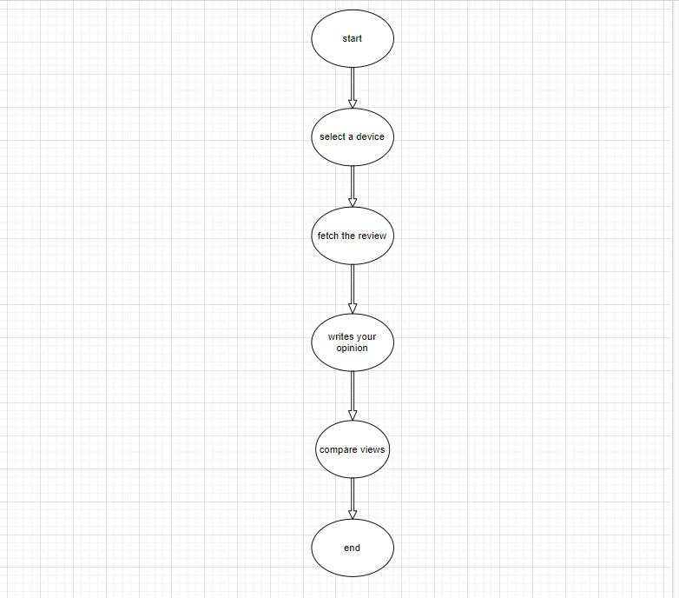

#### 6.2 use case diagram

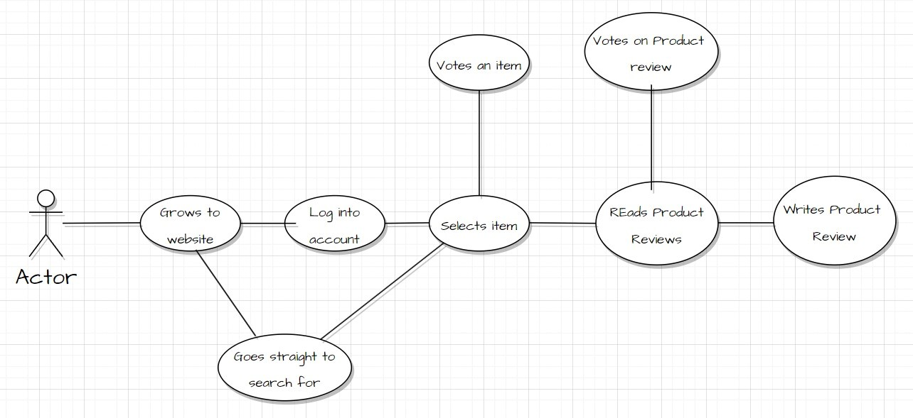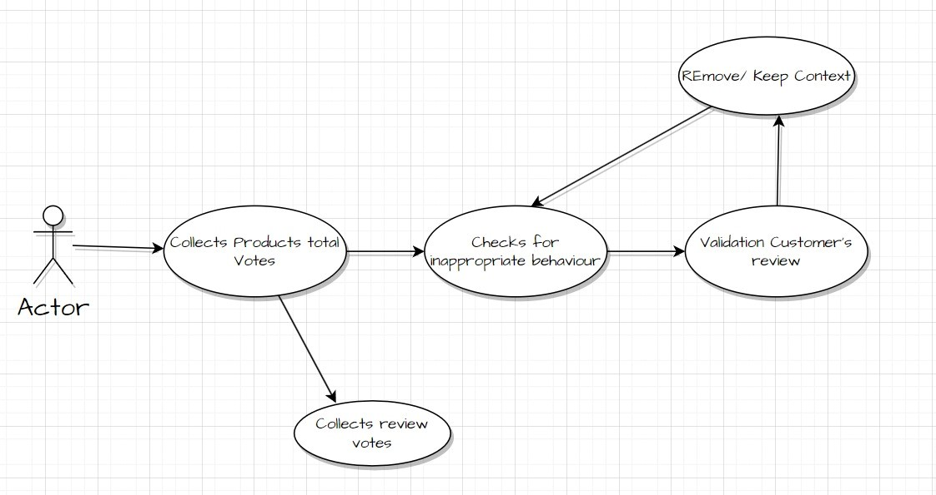



### 7.CODING

### import pandas as pd

### import random

### # Step 1: Define categories, products, and descriptions

### categories = {

### "Phones": ["iPhone 15", "Moto G73", "OnePlus 12", "Realme GT 5", "Redmi Note 13", "JioBharat Phone", "iQOO Neo 7"],

### "Laptops": ["Apple MacBook Air", "Dell XPS 13", "HP Pavilion", "Asus ROG Zephyrus", "Lenovo IdeaPad", "Acer Aspire 7"],

### "Televisions": ["Samsung QLED", "Sony Bravia", "LG OLED", "OnePlus TV", "Realme Smart TV"],

### "Refrigerators": ["Samsung Double Door", "LG InstaView", "Whirlpool Frost-Free", "Godrej EdgePro"],

### "Washing Machines": ["Bosch Front Load", "LG TwinWash", "Whirlpool Stainwash", "Samsung EcoBubble"],

### "Air Conditioners": ["Daikin Inverter AC", "LG DualCool", "Samsung WindFree", "Voltas Split AC", "Blue Star AC"],

### "Gaming Consoles": ["PlayStation 5", "Xbox Series X", "Nintendo Switch OLED"],

### "Smart Watches": ["Samsung Galaxy Watch 5", "Garmin Forerunner 945", "Fossil Gen 6"],

### }



### descriptions = {

### "Phones": "Feature-packed phone with fast processor, excellent camera, and long battery life.",

### "Laptops": "High-performance laptop suitable for gaming, productivity, and everyday use.",

### "Televisions": "Smart TV with 4K resolution, vibrant colors, and immersive sound.",

### "Refrigerators": "Energy-efficient refrigerator with spacious compartments and advanced cooling technology.",

### "Washing Machines": "Efficient washing machine with quick wash cycles and silent operation.",

### "Air Conditioners": "Powerful air conditioner with energy-saving inverter technology.",

### "Gaming Consoles": "High-performance gaming consoles for an immersive gaming experience.",

### "Smart Watches": "Stylish and feature-rich smartwatches for fitness tracking and smartphone integration.",

### }

### reviews = [

### "Excellent product! Works perfectly as described.",

### "Amazing product! Exceeded my expectations.",



### "Good value for money, but could be better.",

### "Product is decent, but could use some improvements.",

### "Not happy with the build quality. Needs improvement.",

### "The performance is top-notch, but the price is a bit high.",

### "Delivery was quick, and the product exceeded my expectations."

### ]

### # Step 2: Generate dataset

### def generate_dataset(categories, descriptions, reviews):

### dataset = []

### for category, products in categories.items():

### for product in products:

### price_min = random.randint(1000, 50000)

### price_max = price_min + random.randint(1000, 50000)

### dataset.append({

### "Product Name": product,

### "Category": category,



### "Description": descriptions[category],

### "Price": f"₹{price_min:,} - ₹{price_max:,}",

### "User Feedback": "\n \n \n ".join(random.sample(reviews, 3)),  # Initialize with three random reviews

### "Compare Views": ""

### })

### return pd.DataFrame(dataset)

### # Step 3: Save the dataset

### dataset = generate_dataset(categories, descriptions, reviews)

### dataset.to_csv("large_combined_products_reviews.csv", index=False)

### print("\nDataset saved as 'large_combined_products_reviews.csv'")



#### 7.1.1 RUNNING THE DATASET FOR GENERATING THE CSV FILE

Product Name,Category,Description,Price,User Feedback,Compare Views

iPhone 15,Phones,"Feature-packed phone with fast processor, excellent camera, and long battery life.","₹31,563 - ₹34,580","Good value for money, but could be better.

 The performance is top-notch, but the price is a bit high.

 Excellent product! Works perfectly as described.",

Moto G73,Phones,"Feature-packed phone with fast processor, excellent camera, and long battery life.","₹26,710 - ₹67,640","Not happy with the build quality. Needs improvement.

 Good value for money, but could be better.

 Amazing product! Exceeded my expectations. | excellent","Previous: Not happy with the build quality. Needs improvement.

 Good value for money, but could be better.

 Amazing product! Exceeded my expectations. | New: excellent"

OnePlus 12,Phones,"Feature-packed phone with fast processor, excellent camera, and long battery life.","₹8,154 - ₹43,988","Good value for money, but could be better.

 Excellent product! Works perfectly as described.

 Amazing product! Exceeded my expectations.",

Realme GT 5,Phones,"Feature-packed phone with fast processor, excellent camera, and long battery life.","₹3,971 - ₹41,142","Good value for money, but could be better.

 Excellent product! Works perfectly as described.

 Delivery was quick, and the product exceeded my expectations.",

Redmi Note 13,Phones,"Feature-packed phone with fast processor, excellent camera, and long battery life.","₹13,353 - ₹48,910","Excellent product! Works perfectly as described.

 Amazing product! Exceeded my expectations.

 The performance is top-notch, but the price is a bit high.",

JioBharat Phone,Phones,"Feature-packed phone with fast processor, excellent camera, and long battery life.","₹45,658 - ₹78,028","The performance is top-notch, but the price is a bit high.

 Delivery was quick, and the product exceeded my expectations.

 Not happy with the build quality. Needs improvement.",

iQOO Neo 7,Phones,"Feature-packed phone with fast processor, excellent camera, and long battery life.","₹38,533 - ₹76,650","The performance is top-notch, but the price is a bit high.

 Product is decent, but could use some improvements.



 Not happy with the build quality. Needs improvement.",

Apple MacBook Air,Laptops,"High-performance laptop suitable for gaming, productivity, and everyday use.","₹37,466 - ₹42,601","Excellent product! Works perfectly as described.

 Not happy with the build quality. Needs improvement.

 Good value for money, but could be better.",

Dell XPS 13,Laptops,"High-performance laptop suitable for gaming, productivity, and everyday use.","₹48,449 - ₹55,995","Delivery was quick, and the product exceeded my expectations.

 Amazing product! Exceeded my expectations.

 Not happy with the build quality. Needs improvement.

good | v","Previous: Delivery was quick, and the product exceeded my expectations.

 Amazing product! Exceeded my expectations.

 Not happy with the build quality. Needs improvement.

good | New: v"

HP Pavilion,Laptops,"High-performance laptop suitable for gaming, productivity, and everyday use.","₹43,993 - ₹56,524","Not happy with the build quality. Needs improvement.

 Product is decent, but could use some improvements.

 The performance is top-notch, but the price is a bit high.",

Asus ROG Zephyrus,Laptops,"High-performance laptop suitable for gaming, productivity, and everyday use.","₹38,852 - ₹54,658","The performance is top-notch, but the price is a bit high.

 Excellent product! Works perfectly as described.

 Good value for money, but could be better. | good","Previous: The performance is top-notch, but the price is a bit high.

 Excellent product! Works perfectly as described.

 Good value for money, but could be better. | New: good"

Lenovo IdeaPad,Laptops,"High-performance laptop suitable for gaming, productivity, and everyday use.","₹15,005 - ₹30,041","The performance is top-notch, but the price is a bit high.

 Product is decent, but could use some improvements.

 Good value for money, but could be better.",

Acer Aspire 7,Laptops,"High-performance laptop suitable for gaming, productivity, and everyday use.","₹30,074 - ₹60,822","Product is decent, but could use some improvements.

 Excellent product! Works perfectly as described.

 Amazing product! Exceeded my expectations.",

Samsung QLED,Televisions,"Smart TV with 4K resolution, vibrant colors, and immersive sound.","₹26,768 - ₹72,590","Delivery was quick, and the product exceeded my expectations.

 Not happy with the build quality. Needs improvement.

 Product is decent, but could use some improvements.",



Sony Bravia,Televisions,"Smart TV with 4K resolution, vibrant colors, and immersive sound.","₹25,543 - ₹65,751","Excellent product! Works perfectly as described.

 The performance is top-notch, but the price is a bit high.

 Delivery was quick, and the product exceeded my expectations.",

LG OLED,Televisions,"Smart TV with 4K resolution, vibrant colors, and immersive sound.","₹34,441 - ₹66,922","Good value for money, but could be better.

 The performance is top-notch, but the price is a bit high.

 Product is decent, but could use some improvements. | good","Previous: Good value for money, but could be better.

 The performance is top-notch, but the price is a bit high.

 Product is decent, but could use some improvements. | New: good"

OnePlus TV,Televisions,"Smart TV with 4K resolution, vibrant colors, and immersive sound.","₹38,577 - ₹77,982","Good value for money, but could be better.

 Delivery was quick, and the product exceeded my expectations.

 Product is decent, but could use some improvements.",

Realme Smart TV,Televisions,"Smart TV with 4K resolution, vibrant colors, and immersive sound.","₹33,668 - ₹40,393","Amazing product! Exceeded my expectations.

 Not happy with the build quality. Needs improvement.

 Excellent product! Works perfectly as described.",

Samsung Double Door,Refrigerators,Energy-efficient refrigerator with spacious compartments and advanced cooling technology.,"₹10,598 - ₹33,665","Good value for money, but could be better.

 The performance is top-notch, but the price is a bit high.

 Delivery was quick, and the product exceeded my expectations.",

LG InstaView,Refrigerators,Energy-efficient refrigerator with spacious compartments and advanced cooling technology.,"₹21,606 - ₹39,219","Amazing product! Exceeded my expectations.

 The performance is top-notch, but the price is a bit high.

 Delivery was quick, and the product exceeded my expectations. | osm","Previous: Amazing product! Exceeded my expectations.

 The performance is top-notch, but the price is a bit high.

 Delivery was quick, and the product exceeded my expectations. | New: osm"

Whirlpool Frost-Free,Refrigerators,Energy-efficient refrigerator with spacious compartments and advanced cooling technology.,"₹11,168 - ₹52,358","Excellent product! Works perfectly as described.

 Delivery was quick, and the product exceeded my expectations.

 Product is decent, but could use some improvements. | good","Previous: Excellent product! Works perfectly as described.



 Delivery was quick, and the product exceeded my expectations.

 Product is decent, but could use some improvements. | New: good"

Godrej EdgePro,Refrigerators,Energy-efficient refrigerator with spacious compartments and advanced cooling technology.,"₹43,372 - ₹89,274","Product is decent, but could use some improvements.

 The performance is top-notch, but the price is a bit high.

 Not happy with the build quality. Needs improvement.",

Bosch Front Load,Washing Machines,Efficient washing machine with quick wash cycles and silent operation.,"₹26,683 - ₹72,581","Good value for money, but could be better.

 Excellent product! Works perfectly as described.

 Amazing product! Exceeded my expectations.",

LG TwinWash,Washing Machines,Efficient washing machine with quick wash cycles and silent operation.,"₹3,503 - ₹22,996","Product is decent, but could use some improvements.

 The performance is top-notch, but the price is a bit high.

 Good value for money, but could be better. | ghhhgh | good","Previous: Product is decent, but could use some improvements.

 The performance is top-notch, but the price is a bit high.

 Good value for money, but could be better. | ghhhgh | New: good"

Whirlpool Stainwash,Washing Machines,Efficient washing machine with quick wash cycles and silent operation.,"₹32,411 - ₹56,760","Delivery was quick, and the product exceeded my expectations.

 Excellent product! Works perfectly as described.

 Good value for money, but could be better. | it's osm","Previous: Delivery was quick, and the product exceeded my expectations.

 Excellent product! Works perfectly as described.

 Good value for money, but could be better. | New: it's osm"

Samsung EcoBubble,Washing Machines,Efficient washing machine with quick wash cycles and silent operation.,"₹18,763 - ₹50,812","Not happy with the build quality. Needs improvement.

 Delivery was quick, and the product exceeded my expectations.

 Product is decent, but could use some improvements.",

Daikin Inverter AC,Air Conditioners,Powerful air conditioner with energy-saving inverter technology.,"₹42,425 - ₹73,045","Good value for money, but could be better.

 Amazing product! Exceeded my expectations.

 The performance is top-notch, but the price is a bit high.",

LG DualCool,Air Conditioners,Powerful air conditioner with energy-saving inverter technology.,"₹26,203 - ₹62,798","Not happy with the build quality. Needs improvement.

 Good value for money, but could be better.



 The performance is top-notch, but the price is a bit high.

excellent","Previous:

Not happy with the build quality. Needs improvement.

 Good value for money, but could be better.

 The performance is top-notch, but the price is a bit high.

New:

excellent"

Samsung WindFree,Air Conditioners,Powerful air conditioner with energy-saving inverter technology.,"₹30,169 - ₹55,190","Good value for money, but could be better.

 The performance is top-notch, but the price is a bit high.

 Delivery was quick, and the product exceeded my expectations.

good","Previous:

Good value for money, but could be better.

 The performance is top-notch, but the price is a bit high.

 Delivery was quick, and the product exceeded my expectations.

New:

good"

Voltas Split AC,Air Conditioners,Powerful air conditioner with energy-saving inverter technology.,"₹18,951 - ₹57,174","Excellent product! Works perfectly as described.

 Delivery was quick, and the product exceeded my expectations.

 Product is decent, but could use some improvements.",

Blue Star AC,Air Conditioners,Powerful air conditioner with energy-saving inverter technology.,"₹10,812 - ₹52,283","The performance is top-notch, but the price is a bit high.

 Delivery was quick, and the product exceeded my expectations.

 Not happy with the build quality. Needs improvement.",

PlayStation 5,Gaming Consoles,High-performance gaming consoles for an immersive gaming experience.,"₹24,099 - ₹41,101","Product is decent, but could use some improvements.

 Excellent product! Works perfectly as described.

 Delivery was quick, and the product exceeded my expectations.",

Xbox Series X,Gaming Consoles,High-performance gaming consoles for an immersive gaming experience.,"₹17,064 - ₹47,831","Excellent product! Works perfectly as described.

 Product is decent, but could use some improvements.

 Not happy with the build quality. Needs improvement.",

Nintendo Switch OLED,Gaming Consoles,High-performance gaming consoles for an immersive gaming experience.,"₹23,776 - ₹66,992","Good value for money, but could be better.

 Product is decent, but could use some improvements.



 Not happy with the build quality. Needs improvement.",

Samsung Galaxy Watch 5,Smart Watches,Stylish and feature-rich smartwatches for fitness tracking and smartphone integration.,"₹36,252 - ₹54,021","Not happy with the build quality. Needs improvement.

 Amazing product! Exceeded my expectations.

 The performance is top-notch, but the price is a bit high.",

Garmin Forerunner 945,Smart Watches,Stylish and feature-rich smartwatches for fitness tracking and smartphone integration.,"₹22,072 - ₹23,306","Amazing product! Exceeded my expectations.

 Product is decent, but could use some improvements.

 Excellent product! Works perfectly as described.

super product","Previous:

Amazing product! Exceeded my expectations.

 Product is decent, but could use some improvements.

 Excellent product! Works perfectly as described.

New:

super product"

Fossil Gen 6,Smart Watches,Stylish and feature-rich smartwatches for fitness tracking and smartphone integration.,"₹9,131 - ₹30,287","Excellent product! Works perfectly as described.

 Delivery was quick, and the product exceeded my expectations.

 The performance is top-notch, but the price is a bit high.",



#### 7.2 CODE FOR CREATING THE GUI

import tkinter as tk from tkinter import ttk, messagebox import pandas as pd

from PIL import Image, ImageTk

# Load the dataset

csv_file = "large_combined_products_reviews.csv" df = pd.read_csv(csv_file)

# Function to update the products list based on the selected category def update_products_list(event):

selected_category = category_combobox.get()

products = df[df['Category'] == selected_category]['Product Name'].tolist() product_listbox.delete(0, tk.END)

# Clear the listbox

for product in products:

product_listbox.insert(tk.END, product)

# Function to update the product details based on the selected product def update_product_details(event):

selected_product = product_listbox.get(tk.ANCHOR)

# Get the selected product

if not selected_product:

# If no product is selected, do nothing

Return

product_data = df[df['Product Name'] == selected_product].iloc[0]

# Update the labels with product details



product_name_label.config(text=f"Product Name: {product_data['Product Name']}")

product_category_label.config(text=f"Category: {product_data['Category']}") product_price_label.config(text=f"Price: {product_data['Price']}") product_description_label.config(text=f"Description: {product_data['Description']}") user_review_label.config(text=f"User Feedback: {product_data['User Feedback']}") compare_views_label.config(text=f"Compare Views: {product_data['Compare Views']}")

# Function to submit user feedback def submit_feedback():

selected_product = product_listbox.get(tk.ANCHOR)

if not selected_product:

messagebox.showerror("Error", "Please select a product to provide feedback.")

return

# Get the feedback

feedback=feedback_entry.get().strip()

if not feedback:

messagebox.showinfo("Thank You", "Thank you for visiting!")

return

# Do not save empty feedback

# Append feedback to the dataset

global df

product_index = df[df['Product Name'] == selected_product].index[0]

existing_feedback = df.at[product_index, "User Feedback"]

updated_feedback = feedback if not existing_feedback else f"{existing_feedback} | {feedback}"

 df.at[product_index, "User Feedback"] = updated_feedback

 # Update Compare Views column

 compare_views = f"Previous: {existing_feedback if existing_feedback else 'None'} | New: {feedback}" df.at[product_index, "Compare Views"] = compare_views

 # Save the updated DataFrame

 df.to_csv(csv_file, index=False)



    # Update user feedback label

    user_review_label.config(text=f"User Feedback: {updated_feedback}")

    compare_views_label.config(text=f"Compare Views: {compare_views}")

    feedback_entry.delete(0, tk.END)

 # Clear feedback entry

    messagebox.showinfo("Success", "Feedback submitted successfully!")

# Create the main window

root = tk.Tk()

root.title("Tech Review System")

root.geometry("900x950")

# Add main heading and logo

logo_frame = tk.Frame(root)

logo_frame.pack(pady=10)

# Load and display the logo on the left

logo1_image = Image.open("nri logo.jpg").resize((100, 100))

# Adjust path and size

logo1 = ImageTk.PhotoImage(logo1_image)

logo1_label = tk.Label(logo_frame, image=logo1)

logo1_label.pack(side=tk.LEFT, padx=10)

# Add college name and subtitle

college_name_label=tk.Label(logo_frame,text="NRI

INSTITUTE OF TECHNOLOGY\n(AUTONOMOUS)",

font=("Helvetica", 18, "bold"))

college_name_label.pack(side=tk.LEFT, padx=20)

# Label for category selection

category_label = tk.Label(root, text="Select Category", font=("Arial", 14))

category_label.pack(pady=10)

# Combobox to select category

categories = df['Category'].unique().tolist()

category_combobox = ttk.Combobox(root, values=categories, width=50)

category_combobox.bind("<<ComboboxSelected>>", update_products_list)

category_combobox.pack(pady=10)

# Listbox to display products in the selected category

product_listbox = tk.Listbox(root, width=50, height=5)

product_listbox.bind("<<ListboxSelect>>", update_product_details)

product_listbox.pack(pady=10)



# Labels for displaying product details

product_name_label = tk.Label(root, text="Product Name: ", font=("Arial", 12))

product_name_label.pack(pady=5)

product_category_label = tk.Label(root, text="Category: ", font=("Arial", 12))

product_category_label.pack(pady=5)

product_price_label = tk.Label(root, text="Price: ", font=("Arial", 12))

product_price_label.pack(pady=5)

product_description_label=tk.Label(root, text="Description: ", font=("Arial", 12), wraplength=700)

product_description_label.pack(pady=5)

user_review_label = tk.Label(root, text="User Feedback: ", font=("Arial", 12), wraplength=700)

user_review_label.pack(pady=5)

compare_views_label=tk.Label(root, text="Compare Views: ", font=("Arial", 12), wraplength=700)

compare_views_label.pack(pady=5)

# Entry for user feedback

feedback_label = tk.Label(root, text="Your Feedback (Optional):", font=("Arial", 12))

feedback_label.pack(pady=10)

feedback_entry = tk.Entry(root, width=60)

feedback_entry.pack(pady=5)

# Submit feedback button

submit_button = tk.Button(root, text="Submit Feedback", command=submit_feedback, font=("Arial", 12), bg="#ff00ff")

submit_button.pack(pady=10)

# Start the GUI loop

root.mainloop()





2121

##### 8. RESULT

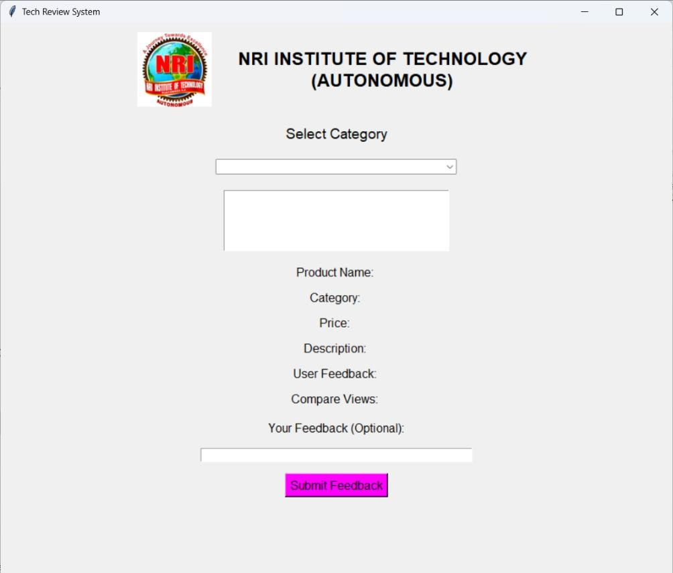

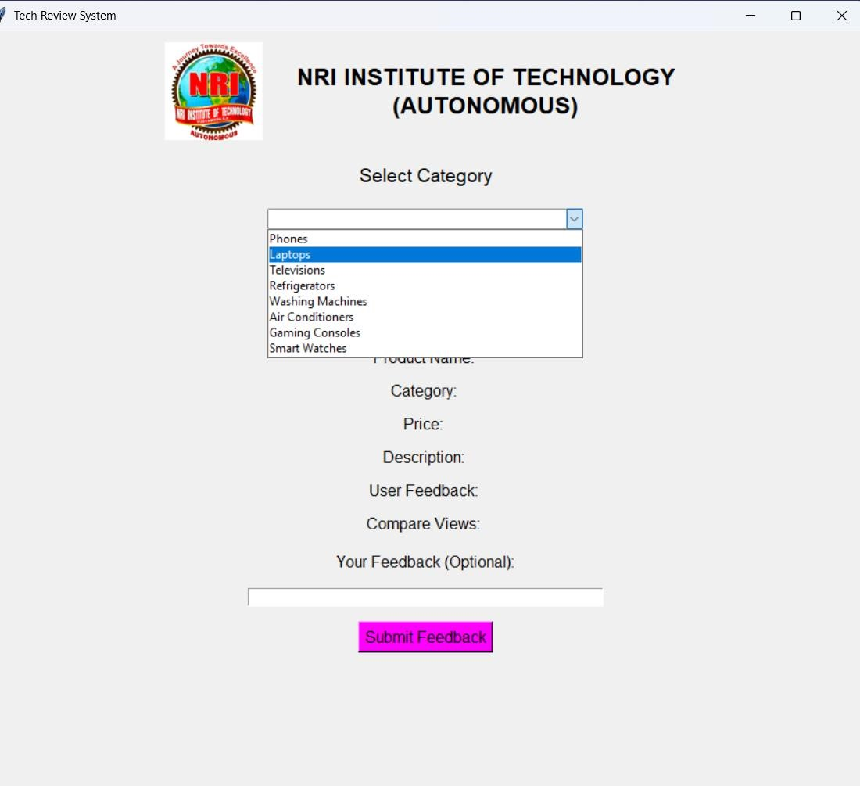

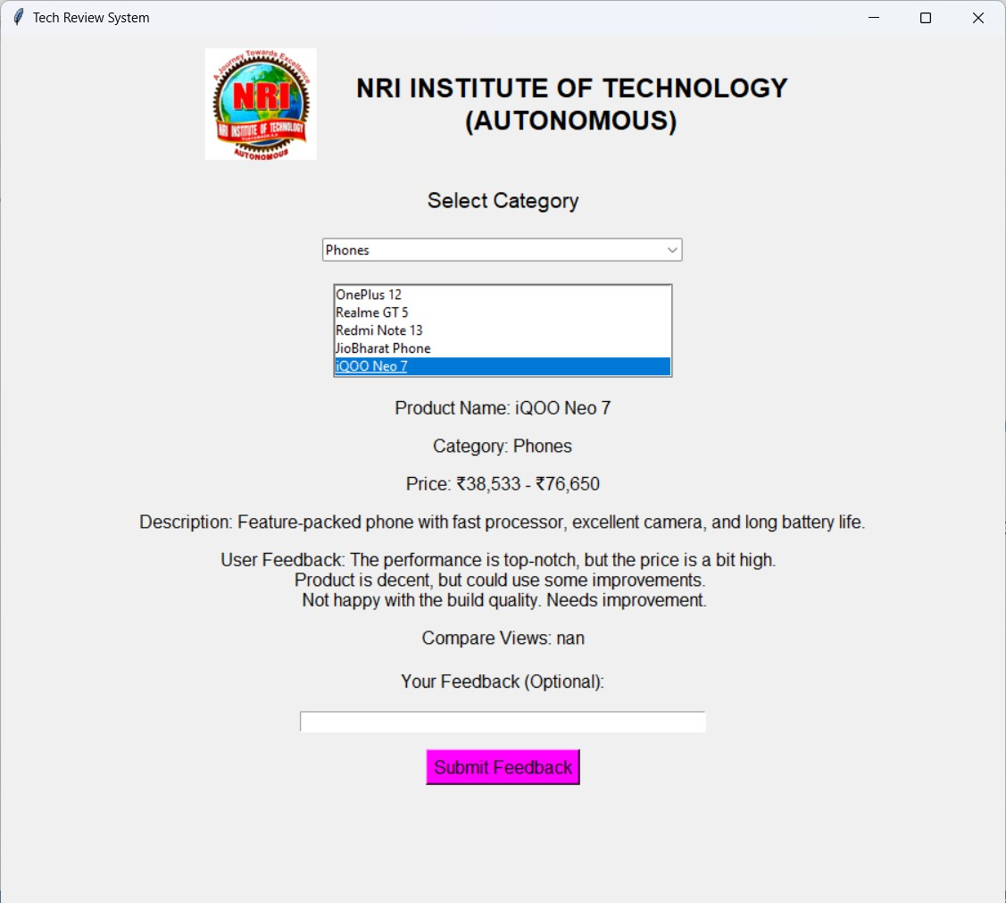



### 9.CHALLENGES FACED

1. **Bias in Reviews**: Personal biases, preferences, or experiences of reviewers may impact the objectivity of the feedback, leading to inconsistent evaluations.
2. **Lack of Standardization**: Without clear guidelines or criteria, reviews can vary significantly in quality and focus, making it hard to ensure fairness and reliability.
3. **Scalability Issues**: As the volume of submissions increases, managing and assigning reviews efficiently becomes a challenge, especially in large organizations or systems.
4. **Reviewer Expertise**: Inadequate domain knowledge or technical expertise of reviewers can lead to inaccurate assessments or overlooked issues.
5. **Time Constraints**: Reviewers often work under tight deadlines, which can compromise the depth and quality of reviews.
6. **Confidentiality Concerns**: Sharing sensitive information during the review process risks breaches of confidentiality or intellectual property issues.
7. **Conflict of Interest**: Reviewers may have prior affiliations or competitive interests that affect their neutrality.
8. **Feedback Quality**: Reviews may lack actionable or constructive feedback, hindering meaningful improvements.
9. **Integration with Development Cycles**: Aligning the review process with agile or iterative development can be challenging without delaying project timelines.
10. **Automation Limitations**: While AI and automation tools can assist, they may fail to understand context or nuances in complex technical submissions.



### 10.CONCLUSION

The Tech Review System represents a significant step forward in simplifying and enhancing the way users engage with and assess technology products. In a world driven by rapid technological advancements and an overwhelming number of device options, such a platform serves as a vital tool for decision-making. By integrating features like device selection, automated review generation, user opinion writing, and comparative analysis, this system provides a holistic solution that caters to the diverse needs of tech enthusiasts, casual buyers, and professionals alike**.**

In conclusion, the Tech Review System is not just a project but a vision of how technology can empower users by simplifying complex decisions. By bridging the gap between data and decision-making, it allows users to make informed choices confidently and efficiently. The system’s modularity, adaptability, and scalability ensure it remains relevant in a fast-paced technological landscape. As the platform evolves, it has the potential to expand into new domains, such as integrating AI-driven personalization or incorporating social engagement features, making it an indispensable tool for anyone navigating the ever-expanding world of technology.







## 11.FUTURE SCOPE

The Tech Review System has immense potential for future growth and expansion, given the rapid pace of technological advancements and increasing user expectations. Several enhancements and features can be introduced to make the platform more robust, user-friendly, and versatile. Below are some key areas for future development:

### 1. Integration of Advanced Artificial Intelligence

Personalized Recommendations: By incorporating AI-driven algorithms, the system can analyze user preferences, browsing history, and purchase behavior to provide tailored device recommendations.

**2.Sentiment Analysis:**

Advanced Natural Language Processing (NLP) models can analyze user-generated reviews to detect sentiment trends and provide a summary of collective opinions.

**3.Review Generation**:

Leveraging AI-powered language models, the system can generate detailed reviews by compiling data from multiple sources and summarizing key insights.

### 4. Enhanced Comparison Features

Custom Comparison Metrics: Users can be given the option to select specific parameters, such as battery life, performance, or camera quality, for personalized device comparisons.

Visualization Tools: Interactive charts, graphs, and heatmaps can be introduced to make comparisons more visually engaging and easier to understand.

### 5. Integration with E-commerce Platforms

Direct Purchase Links: Collaborating with e-commerce platforms to integrate purchase links for devices would make the system more convenient for users.



Real-Time Price Updates: Adding a feature to fetch real-time pricing data and discounts would help users make more informed decisions.

### 6. Mobile Application Development

To increase accessibility, a dedicated mobile application can be developed. The app could include push notifications for price drops, new reviews, or trending devices.

### 7. Community Engagement

**User Forums:** Introducing a space where users can discuss devices, share experiences, and provide peer-to-peer advice would enhance user interaction and engagement.

**Reviews:** Collaborating with tech experts to provide professional insights would add Expert credibility to the platform.

### 8. Multilingual Support

Expanding the platform to support multiple languages would make it accessible to a broader audience, catering to users from diverse linguistic backgrounds.

### 9. Integration of IoT and Smart Devices

The system can be expanded to include reviews and comparisons of IoT devices like smart home systems, wearable tech, and other emerging technologies.

### 10. Advanced Analytics and Insights

Trends Analysis: Introducing tools to analyze and predict trends in the tech industry based on user reviews and market data.User Behavior Insights: Collecting and analyzing user interaction data to continuously improve the platform’s features and user interface.



### 9. Gamification Features

Introducing gamification elements, such as rewards for writing reviews, completing comparisons, or inviting friends, could increase user engagement.

### 10. Collaboration with Manufacturers

Partnering with device manufacturers to obtain exclusive information about upcoming devices and providing early reviews or sneak peeks would make the platform a go-to destination for tech enthusiasts.

### Conclusion

The future scope of the Tech Review System is vast, with numerous opportunities to innovate and expand. By leveraging emerging technologies and addressing user needs, the platform can become a comprehensive and indispensable tool for tech reviews and comparisons, catering to a global audience and keeping pace with the ever-evolving technology landscape.



**CHAPTER**

**-**

**12**

### 12.References & Appendix

#### 12.1 REFERENCES

Below is a list of references that can be included to support the Tech Review System project:

##### 1. Books and Articles

Sommerville, I. (2011). Software Engineering (10th Edition). Pearson Education.

Pressman, R. S. (2014). Software Engineering: A Practitioner's Approach. McGraw-Hill.

Fowler, M. (2002). Patterns of Enterprise Application Architecture. Addison-Wesley Professional.

##### 2. Web Resources

Flask Framework Documentation: https://flask.palletsprojects.com

Django Framework Documentation: https://www.djangoproject.com

ReactJS Documentation: https://reactjs.org

MySQL Documentation: https://dev.mysql.com

MongoDB Documentation: https://www.mongodb.com

TensorFlow for Machine Learning: https://www.tensorflow.org



Google Analytics Setup Guide: https://analytics.google.com

##### 3. Research Papers

"Rapid Application Development: A Historical Perspective" by James Martin, IEEE Publications.

"Agile Development and Its Role in Project Success" by C. Larman and V. Basili, ACM Digital

Library.

##### 4. APIs and Tools

Google APIs for Analytics: <https://developers.google.com/analytics>RESTful API Best Practices:

https://restfulapi.net

#### 12.2 APPENDIX

##### A. Glossary of Terms

1. **Tech Review System:** A platform designed for selecting, reviewing, and comparing technological devices.
2. **MVC Architecture:** A design pattern dividing an application into three interconnected components—Model, View, and Controller.
3. **REST API:** A set of web service APIs that conform to the REST architectural style.
4. **Agile Methodology**: A flexible approach to software development that emphasizes iterative progress and collaboration.
5. **Sentiment Analysis:** A Natural Language Processing (NLP) technique used to determine the emotional tone behind user reviews.



##### B. Tools and Software Used

**Backend:** Python (Flask, Django), MySQL, PostgreSQL

**Frontend:** ReactJS, HTML, CSS

**API’s:** RESTful APIs, Google Analytics API

**Data Analysis:** TensorFlow, Pandas, Matplotlib 30



2121